**Online Diary – Territorial Acquisition Game**

Groups Members – Connor Winspur, Reece Taylor, Yap Hou Yuen (Steve).

**1.0 - Overview and Game Description**

In order to meet the requirements of the task the team created a tile-based conquest game that could be played in different ways, customisable to the player. It was designed with 2 – 4 players in mind, while allowing for more if an appropriate map is used. The idea behind the game was that players sated in opposing corners of the map, expanding outwards across it during their turns, eventually leading them to attack players for their tiles and having to defend their own. To win one must conquer all other capitals or acquire the highest number of tiles by the end of the set amount of turns.

**1.1 - Assets**

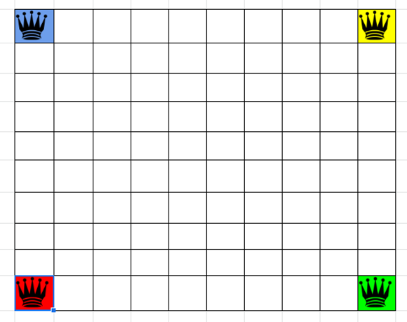

[A]

Figure 1. Default Game Board

This figure shows a basic mock-up of the tile board that can be used for the game. The capitals [A] are in each corner of the map.

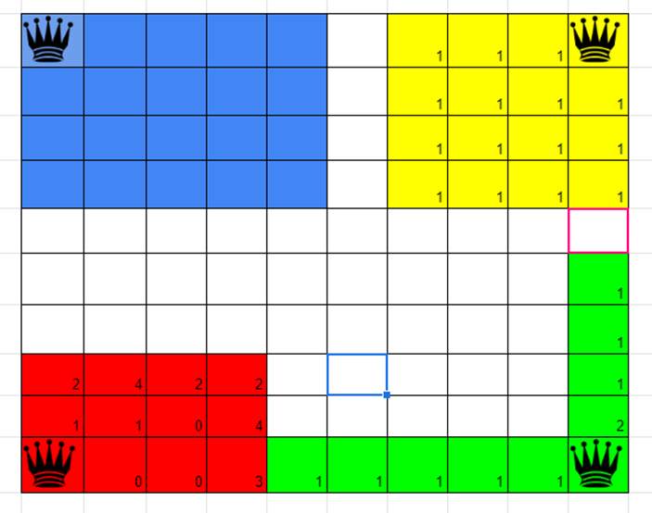

[C]

[B]

[A]

Figure 2. Game Test

This scene shows the game test we performed and the progress of the game.

[A] Shows the capitals.

[B] Shows the tile Conquered.

[C]Shows the unit count in each tile.

**1.2 - Mechanics**

* Token Based Unit system.
* Single Player Conquest.
* One to One Combat System.
* Negotiation and Alliances.
* Resource/ Troop Management.

**1.3 - Materials**

The game is fairly easy to set-up as it only requires a map and a representation for the units in the game. In the most traditional sense, a board featuring the map and tokens representing the units would be the easiest to use for a physical version of the game. However, this game can easily be recreated in many different ways, including electronically, one of which was through the use of excel, as shown in Figure 1 and 2, which the team used for play testing.

**1.4 - Rules**

* Start the game in one corner of the map chosen.
* A default 10x10 map size that can be changed based on the players preference.
* Thirty turns are the default for each game (can be changed)
* Each player starts with three-unit tokens.
* A player can only have a maximum of five units placed on a single tile.
* Units can only move one tile per turn.
* At the start of each turn players get a default of one-unit tokens to deploy on any tile they own.
* Each starting tile is a capital that provides two unit tokens a turn, losing the capital means you lose this bonus and the player conquering it gains that bonus.
* For every three tiles owned players gain an extra unit token per turn.

**1.5 - Experience and Skills Learnt**

During this session communication between the members of the team had improved, due to the fact that all the members could use voice chat, allowing for the quick trading of ideas and information. However, when it came to effectively organising tasks and the time to do them the team fell short. This week the group managed to complete some play testing which further highlighted the inexperience of the group, in both the initial problems the game faced and the ability for the group to come up with appropriate solutions for these problems. Overall issues with communication and time management have reduced but lack of experience in these fields and others hamper the groups ability to develop games for the tasks set.